SPRINT 1

Creating Registration & Login page for MediZone App

|  |  |
| --- | --- |
| Team ID | PNT2022TMID43478 |
| Project Name | Personal Assistance For Seniors Who Are Self Reliant |

Registration Form:

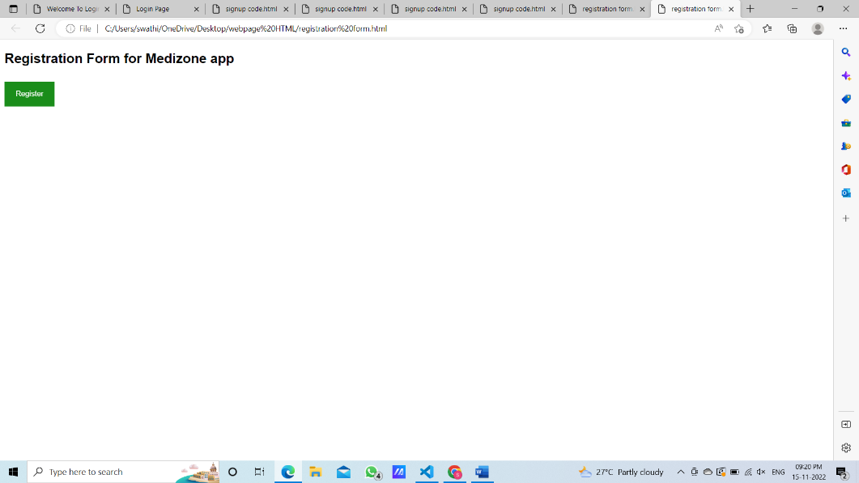

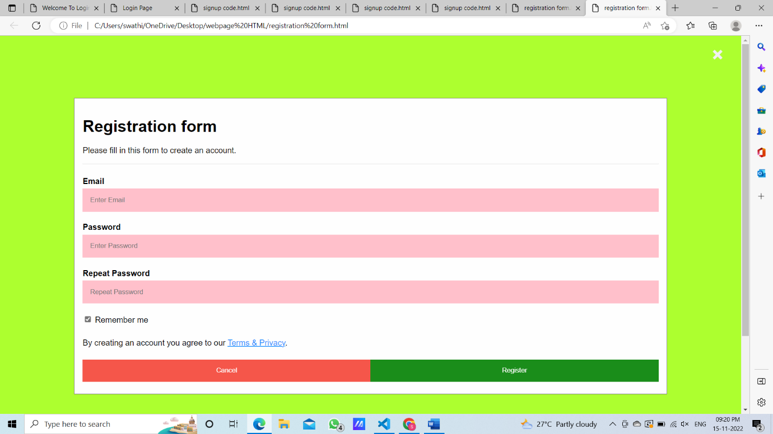

Login Form:

